2nd Edition 2009
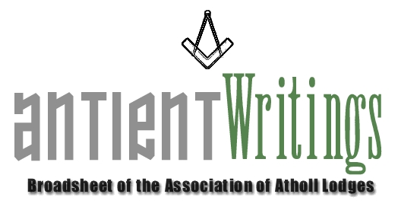

Annual General Meeting

The 2009 Annual General Meeting was held at Freemasons Hall, Gt Queen Street, on Wed 1st July. The Chairman gave an upbeat report and noted the visits the Association had made and how well they had been received including the trip to the Grand Lodge of Ireland. Subscriptions would remain unchanged at £10 and £5 for 2010. Succession planning and new blood was now becoming urgent. Interested brethren are asked to make contact with the Secretary.

New Membership Secretary’s Appeal – Please renew your Subscription

The 2009 renewals are overdue. The fees are £10 for all categories and £5 for individuals. Terry has written to remind secretaries and trusts they will respond favourably. A second ‘chase’ letter is in this mailing ! He can be contacted at 6 St. Matthews Drive, St. Leonard’s on Sea, East Sussex, TN38 0TR. Tel: No. 01424 713004. Email: terrymahoney@btinternet.com

Web Site - www.antients.co.uk or webmaster@antients.co.uk and secretary@antients.co.uk

Due to Lycos exiting from the email business the dot com domain name was lost. We are now .co.uk [as above]

Autumn Unique Event ! !

This Association event will be hosted by Kent Lodge No15. Please circulate widely and try to attend and submit a question. Full details as per enclosed Flyer/Booking Form:

QuestionTime

FREEMASONS’ HALL - GREAT QUEEN STREET – LONDON

WEDNESDAY 14th OCTOBER 2009

3.15 pm OPEN / CLOSE LODGE [Pre MAIN EVENT] - REGALIA
3.50 pm ARRIVAL for EVENT – NON-REGALIA
4.00 pm QUESTIONTIME with PRE-SUBMITTED & FLOOR
QUESTIONS CO-ORDINATED by the QUESTIONMASTER
6.30 pm CLOSING COMMENTS
6.40 pm DEPART for RECEPTION & DRINKS
7.30 pm FESTIVE BOARD at the NEW CONNAUGHT ROOMS

THE PANEL SUBJECT TO AVAILABILITY WILL CONSIST OF
EMINENT MASONS AND RULERS OF THE CRAFT

ASSISTANT GRAND MASTER
GRAND SECRETARY
METROPOLITAN GRAND MASTER
DIRECTOR of SPECIAL PROJECTS
PM QUATUOR CORONATI LODGE 2076
EDITOR FREEMASONRY TODAY
PROVINCIAL GRAND MASTER for WEST KENT
MASONIC CHARITIES REPRESENTATIVE

Merchandise

Ties / Bow Ties / Lapel Pins are available from the Secretary. They are £12.50 and £2.50 respectively. There is also a ‘longer’ version of the tie available. The book on the life of Laurence Dermott is also available at £6 inc UK postage.
You are permitted to wear Association ties at Atholl meetings.

Would Secretaries and Representatives photocopy and distribute as widely as possible

Paul Gardner - 39 Wentworth Drive, Bedford, BEDS, MK41 8QA - 01234 261584 secretary@antients.co.uk

